For Immediate Release
West Mountain Sign is proud to announce our new product line—Hand Knit Signage! Owner Kelly Yamanishi has decided to blend her love of and experience with knitting and fiber arts and the high quality unique signage our customers have come to expect.
Signs, banners, and dimensional letters will be available in a variety of sizes and fibers. Felted 100% Icelandic Wool is recommended for longer term outdoor use, while a loose knit of acrylic or even cotton string can suffice for interior use and special events. Wool dimensional letters on natural wood sign faces offer a stunning and unique organic presence.
In order to manage the cost of this highly specialized process, we have entered into a completely unique and groundbreaking agreement for off shore production in Great Britain. Many British pensioners, with their health care handled and financial support in place, are quite happy to earn a little extra by knitting signage from detailed designs sent across the pond from California.
“It’s wonderful for me,” says Beatrice Grant-Spencer. “After years of knitting jumpers and vests for unappreciative grandchildren, I can now enjoy hours of knitting, not have to buy any wool, and even get paid a few bob!” Grant-Spencer is connected with British Knitting Grannies, a group of knitters who spend their days, needles in hand, knitting, chatting, and dispensing advice to the younger generation.
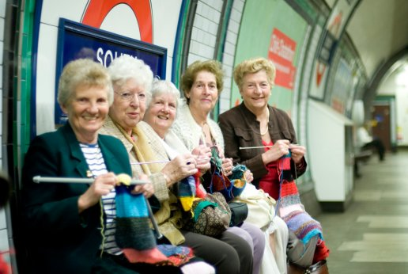
The off shore production agreement allows our Hand Knit Signage to be delivered at surprisingly affordable prices. Hand knit signs are especially prized by gourmet cafes, boutiques, and small businesses with vintage style brands. For more information, visit our website, www.westmountainsign.com, or email us info@westmountainsign.com.

